**Introduction to “brain tumor segmentation project”**

A **glioma** is a type of [tumor](https://en.wikipedia.org/wiki/Tumor) that starts in the [brain](https://en.wikipedia.org/wiki/Human_brain) or [spine](https://en.wikipedia.org/wiki/Vertebral_column). It is called a glioma because it arises from [glial cells](https://en.wikipedia.org/wiki/Glial_cell).

**Neuroglia**, also called **glial cells:**

[**https://www.youtube.com/watch?v=fHY6PV-gBNM**](https://www.youtube.com/watch?v=fHY6PV-gBNM) **- until 5min**

Are non-[neuronal](https://en.wikipedia.org/wiki/Neuron) [cells](https://en.wikipedia.org/wiki/Cell_(biology)) that maintain [homeostasis](https://en.wikipedia.org/wiki/Homeostasis), form [myelin](https://en.wikipedia.org/wiki/Myelin), and provide support and protection for [neurons](https://en.wikipedia.org/wiki/Neuron) in the [central](https://en.wikipedia.org/wiki/Central_nervous_system) and [peripheral nervous systems](https://en.wikipedia.org/wiki/Peripheral_nervous_system).

In the central nervous system, glial cells include [oligodendrocytes](https://en.wikipedia.org/wiki/Oligodendrocyte), [astrocytes](https://en.wikipedia.org/wiki/Astrocyte), [ependymal cells](https://en.wikipedia.org/wiki/Ependymal_cell) and [microglia](https://en.wikipedia.org/wiki/Microglia).

[Neuroscience](https://en.wikipedia.org/wiki/Neuroscience) currently identifies four main functions of glial cells:

1. To surround neurons and hold them in place
2. To supply [nutrients](https://en.wikipedia.org/wiki/Nutrients) and [oxygen](https://en.wikipedia.org/wiki/Oxygen) to neurons
3. To insulate one neuron from another
4. To destroy [pathogens](https://en.wikipedia.org/wiki/Pathogens) and remove dead neurons.

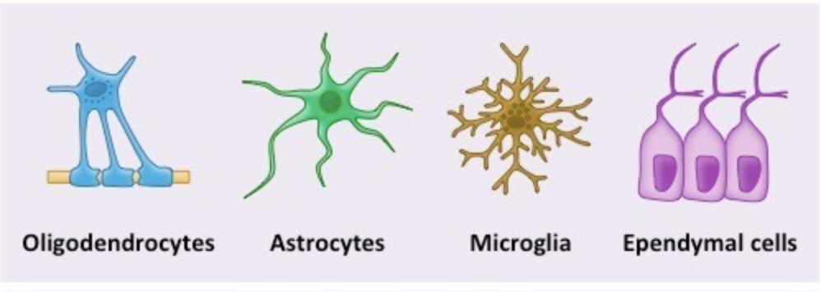

[Oligoden]drocytes](https://en.wikipedia.org/wiki/Oligodendrocyte) –are cells that coat axons in the [central nervous system](https://en.wikipedia.org/wiki/Central_nervous_system) (CNS) with their cell membrane, forming a specialized membrane differentiation called [myelin](https://en.wikipedia.org/wiki/Myelin). The myelin sheath provides [insulation](https://en.wikipedia.org/wiki/Electrical_insulation) to the axon

[Astrocytes](https://en.wikipedia.org/wiki/Astrocyte) . Astrocytes are a type of glial cells and they hold various roles: mostly supporting [neurons](https://en.wikipedia.org/wiki/Neuron), provision of nutrients to the nervous tissue, maintenance of extracellular ion balance, and a role in the repair and scarring process of the brain.

[Ependymal cells](https://en.wikipedia.org/wiki/Ependymal_cell) –  line the spinal cord and the [ventricular system](https://en.wikipedia.org/wiki/Ventricular_system) of the brain. These cells are involved in the creation and secretion of [cerebrospinal fluid](https://en.wikipedia.org/wiki/Cerebrospinal_fluid) (CSF) and beat their [cilia](https://en.wikipedia.org/wiki/Cilia) to help circulate the CSF and make up the [blood-CSF barrier](https://en.wikipedia.org/wiki/Blood-CSF_barrier).

Microglia - they act as the first and main form of active immune defense in the [central nervous system](https://en.wikipedia.org/wiki/Central_nervous_system) (CNS).[[3]](https://en.wikipedia.org/wiki/Microglia#cite_note-Filiano_2015-3) Microglia

**The ventricular system** - a set of four interconnected cavities (ventricles) in the [brain](https://en.wikipedia.org/wiki/Brain), where the [cerebrospinal fluid](https://en.wikipedia.org/wiki/Cerebrospinal_fluid) (CSF) is produced. The ventricular system is continuous with the [central canal](https://en.wikipedia.org/wiki/Central_canal_of_spinal_cord) of the [spinal cord](https://en.wikipedia.org/wiki/Spinal_cord) (from the fourth ventricle) allowing for the flow of CSF to circulate.

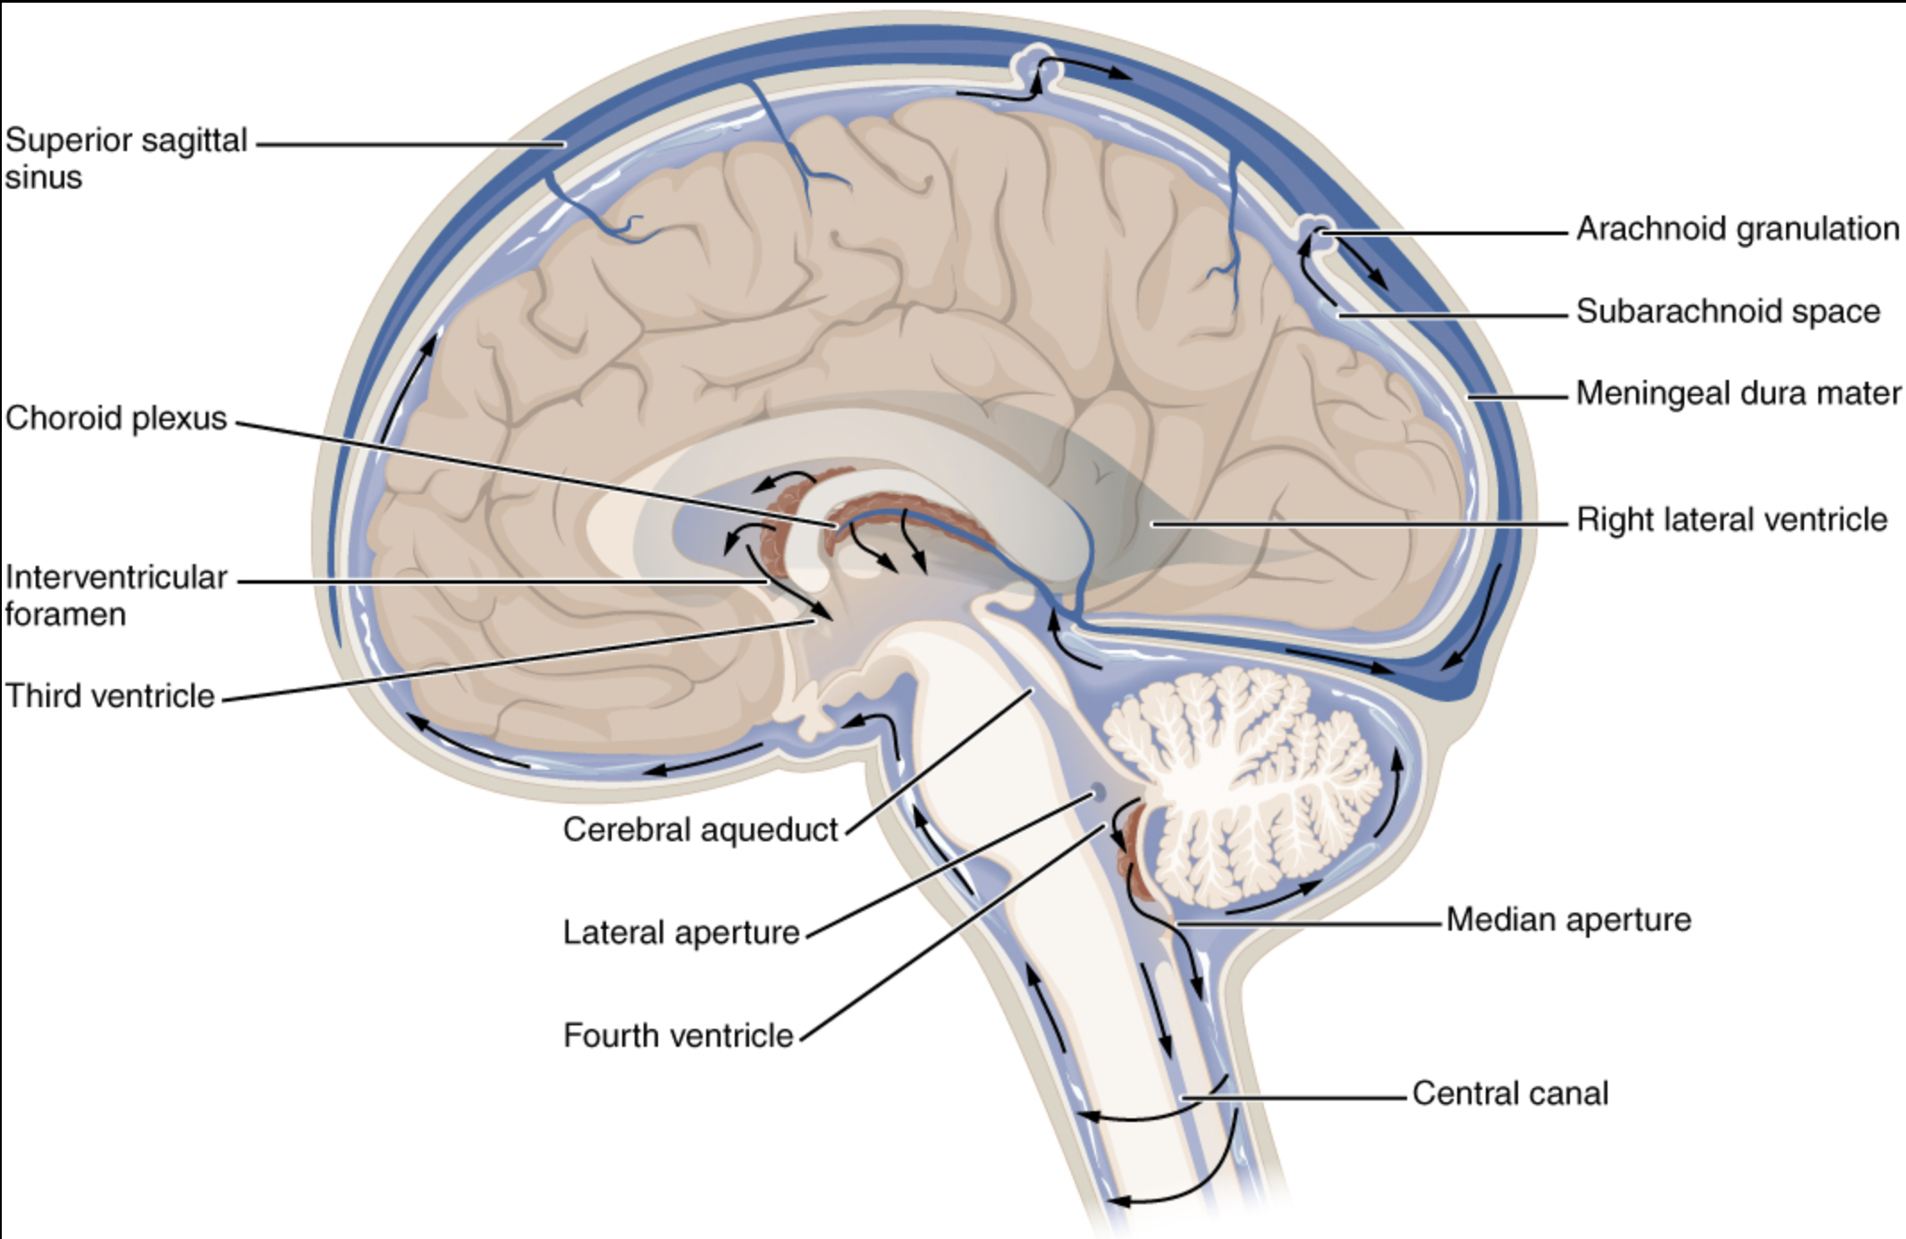

Gliomas are named according to the specific type of cell with which they share histological features, but not necessarily from which they originate. The main types of gliomas are:[[3]](https://en.wikipedia.org/wiki/Glioma#cite_note-3)

* [Ependymomas](https://en.wikipedia.org/wiki/Ependymoma): [ependymal cells](https://en.wikipedia.org/wiki/Ependymal_cell)
* [Astrocytomas](https://en.wikipedia.org/wiki/Astrocytoma): [astrocytes](https://en.wikipedia.org/wiki/Astrocyte) ([glioblastoma multiforme](https://en.wikipedia.org/wiki/Glioblastoma_multiforme) is a malignant astrocytoma and the most common primary brain tumor among adults).
* [Oligodendrogliomas](https://en.wikipedia.org/wiki/Oligodendroglioma): [oligodendrocytes](https://en.wikipedia.org/wiki/Oligodendrocyte)
* [Brainstem glioma](https://en.wikipedia.org/wiki/Brainstem_glioma): develop in the brain stem
* Optic nerve glioma: develop in or around the optic nerve
* Mixed gliomas, such as [oligoastrocytomas](https://en.wikipedia.org/wiki/Oligoastrocytomas), contain cells from different types of glia

Gliomas can be classified according to whether they are above or below a membrane in the brain called the [tentorium](https://en.wikipedia.org/wiki/Tentorium_cerebelli). The tentorium separates the [cerebrum](https://en.wikipedia.org/wiki/Cerebrum) (above) from the [cerebellum](https://en.wikipedia.org/wiki/Cerebellum) (below).

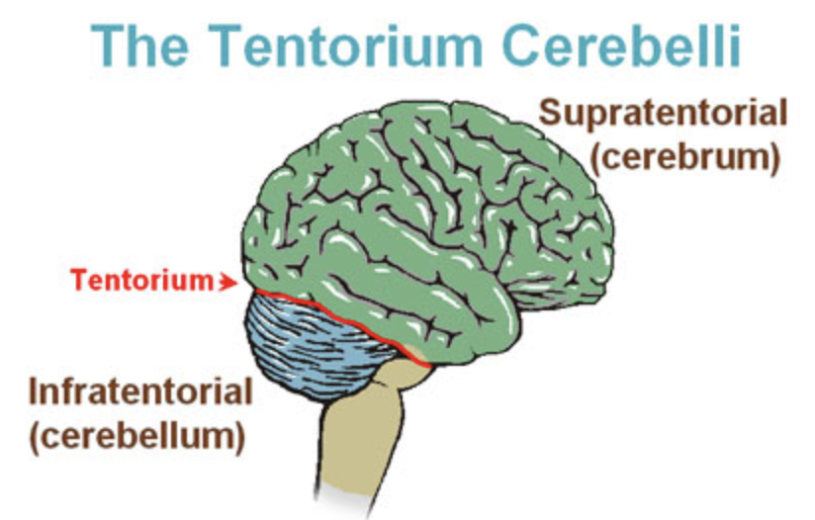

* The [supratentorial](https://en.wikipedia.org/wiki/Supratentorial) is above the tentorium, in the cerebrum, and mostly found in adults (70%).
* The [infratentorial](https://en.wikipedia.org/wiki/Infratentorial) is below the tentorium, in the cerebellum, and mostly found in children (70%).
* The pontine tumors are located in the [pons](https://en.wikipedia.org/wiki/Pons) of the brainstem. The brainstem has three parts (pons, midbrain, and medulla); the pons controls critical functions such as breathing, making surgery on these extremely dangerous.

Magnetic resonance imaging

[medical imaging](https://en.wikipedia.org/wiki/Medical_imaging) technique used in [radiology](https://en.wikipedia.org/wiki/Radiology) to form pictures of the [anatomy](https://en.wikipedia.org/wiki/Anatomy) and the physiological processes of the body in both health and disease. MRI scanners use strong [magnetic fields](https://en.wikipedia.org/wiki/Magnetic_field), [radio waves](https://en.wikipedia.org/wiki/Radio_wave), and [field gradients](https://en.wikipedia.org/wiki/Field_gradient) to generate images of the organs in the body.

[**https://www.youtube.com/watch?v=rumRGO_2H0E**](https://www.youtube.com/watch?v=rumRGO_2H0E)

[**https://www.youtube.com/watch?v=mOt2FeGHjaY**](https://www.youtube.com/watch?v=mOt2FeGHjaY)

|  |  |  |  |  |  |
| --- | --- | --- | --- | --- | --- |
| [T1 weighted image](https://en.wikipedia.org/wiki/Magnetic_resonance_imaging#T1_and_T2) | T1 | Measuring [spin–lattice relaxation](https://en.wikipedia.org/wiki/Spin%E2%80%93lattice_relaxation) by using a short [repetition time](https://en.wikipedia.org/wiki/Repetition_time) (TR) and [echo time](https://en.wikipedia.org/wiki/Echo_time) (TE) | * Lower signal for more water content, [11]as in [edema](https://en.wikipedia.org/wiki/Edema), [tumor](https://en.wikipedia.org/wiki/Tumor), [infarction](https://en.wikipedia.org/wiki/Infarction), * [inflammation](https://en.wikipedia.org/wiki/Inflammation), [infection](https://en.wikipedia.org/wiki/Infection), hyperacute or chronic [hemorrhage](https://en.wikipedia.org/wiki/Hemorrhage) [12] * High signal for [fat](https://en.wikipedia.org/wiki/Fat)[11][12] * High signal for [paramagnetic](https://en.wikipedia.org/wiki/Paramagnetism) substances, such as [MRI contrast agents](https://en.wikipedia.org/wiki/MRI_contrast_agent)[12] | |  |
| [T2 weighted image](https://en.wikipedia.org/wiki/Magnetic_resonance_imaging#T1_and_T2) | T2 | Measuring [spin–spin relaxation](https://en.wikipedia.org/wiki/Spin%E2%80%93spin_relaxation) by using long TR and TE times. | * Higher signal for more water content.[11] * Low signal for fat.[11] * Low signal for [paramagnetic](https://en.wikipedia.org/wiki/Paramagnetism) substances.[12] | |  |
| [Fluid attenuated inversion recovery](https://en.wikipedia.org/wiki/Fluid_attenuated_inversion_recovery) | FLAIR | Fluid suppression by setting an inversion time that nulls fluids. | High signal in [lacunar infarction](https://en.wikipedia.org/wiki/Lacunar_stroke), [multiple sclerosis (MS) plaques](https://en.wikipedia.org/wiki/Multiple_sclerosis), [subarachnoid haemorrhage](https://en.wikipedia.org/wiki/Subarachnoid_hemorrhage) and [meningitis](https://en.wikipedia.org/wiki/Meningitis) (pictured).[67] |  | | |

1. The “edema” was segmented primarily from T2 images. FLAIR was used to cross-check the extension of the edema and discriminate it against ventricles and other fluid-filled structures. The initial “edema” segmentation in T2 and FLAIR contained the core structures that were then relabeled in subsequent steps [Fig. 3(A)].
2. As an aid to the segmentation of the other three tumor substructures, the so-called gross tumor core—including both enhancing and non-enhancing structures—was first segmented by evaluating hyper-intensities in T1c (for high-grade cases) together with the inhomogenous component of the hyper-intense lesion visible in T1 and the hypo-intense regions visible in T1 [Fig. 3(B)].
3. The “enhancing core” of the tumor was subsequently segmented by thresholding T1c intensities within the resulting gross tumor core, including the Gadolinium enhancing tumor rim and excluding the necrotic center and vessels. The appropriate intensity threshold was determined visually on a case-by-case basis [Fig. 3(C)].
4. The “necrotic (or fluid-filled) core” was defined as the tortuous, low intensity necrotic structures within the enhancing rim visible in T1c. The same label was also used for the very rare instances of hemorrhages in the BRATS data [Fig. 3(C)].
5. Finally, the “non-enhancing (solid) core” structures were defined as the remaining part of the gross tumor core, i.e., after subtraction of the “enhancing core” and the “necrotic (or fluid-filled) core” structures [Fig. 3(D)].

Segmentation flow:

Edema [T2 and cross-validate FLAIR]

Tumor core [T1c T1]

Enhancing core [T1c]

Necrotic/cystic core [T1c]

Non-enhancing core [subtract the necrotic and the enhancing from the core]

For evaluating the performance of the segmentation algorithms, however, we grouped the different structures into three mutually inclusive tumor regions that better represent the clinical application tasks, for example, in tumor volumetry. We obtain

1. the “whole” tumor region (including all four tumor structures),
2. the tumor “core” region (including all tumor structures except “edema”),
3. and the “active” tumor region (only containing the “enhancing core” structures that are unique to high-grade cases).

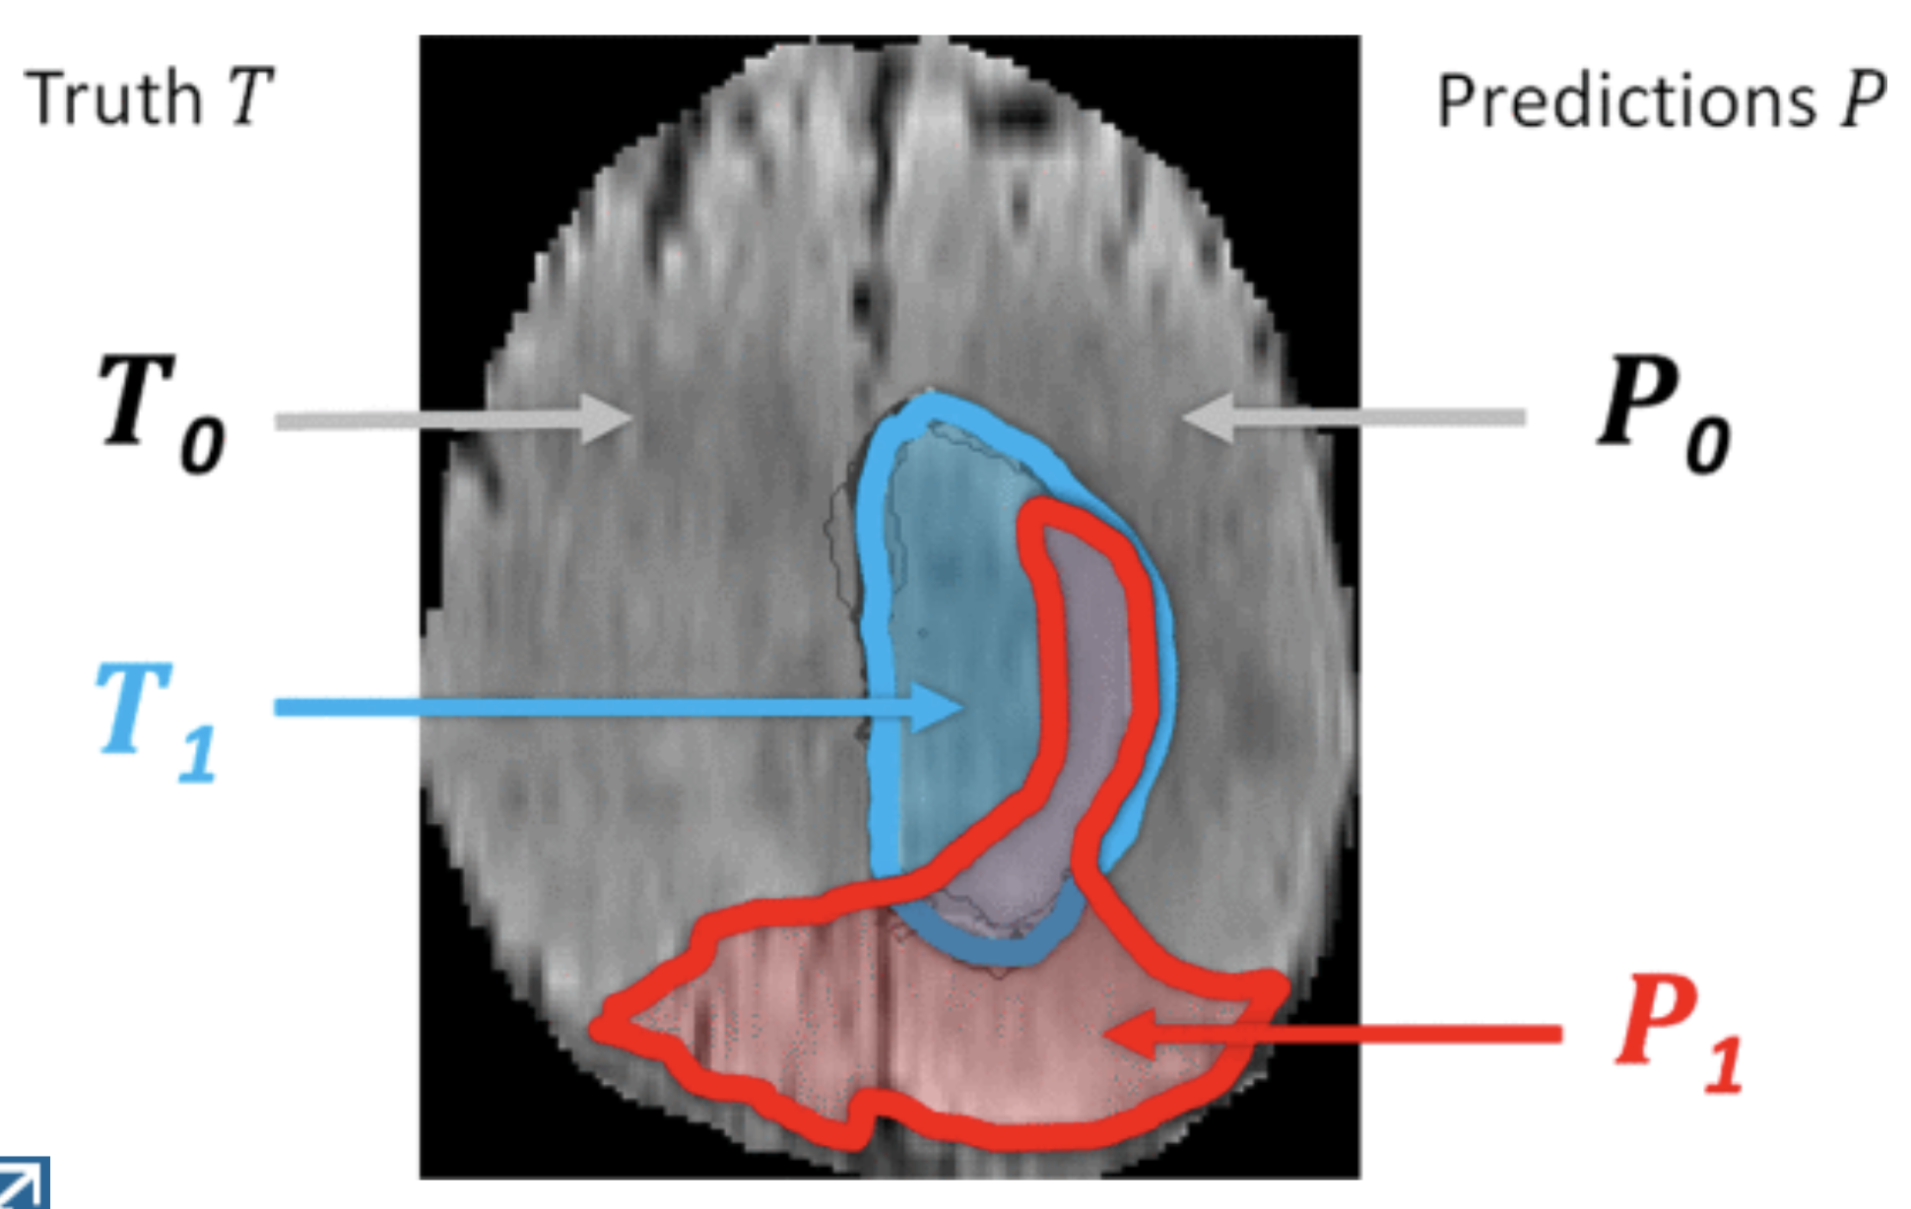

Dice(P,T)=|P1∧T1|/(|P1|+|T1|)/2

Sens(P,T)=|P1∧T1|/|T1| Spec(P,T)=|P0∧T0|/|T0|

Hausdorff distance calculating for all points p on the surface ∂P1 of a given volume P1 the shortest least-squares distance d(p,t) to points t on the surface ∂T1 of the other given volume T1, and vice versa, finally returning the maximum value over all d :

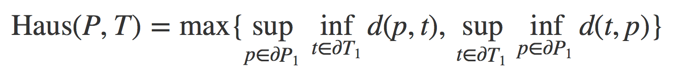

To this end we used a robust version of the Hausdorff measure—reporting not the maximal surface distance between P1 and T1, but the 95% quantile of it.

Q :

Following this protocol, the MRI scans were annotated by a trained team of radiologists and altogether seven radiographers in Bern, Debrecen and Boston. They outlined structures in every third axial slice, interpolated the segmentation using morphological operators (region growing),